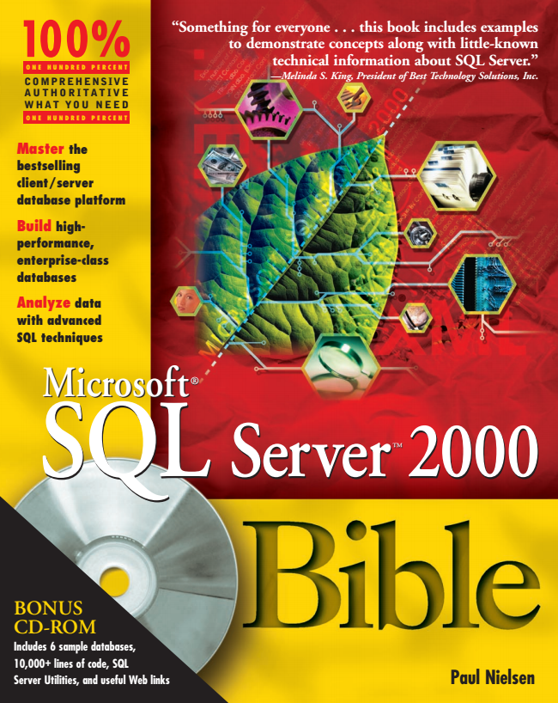

**“Something for everyone . . . this book includes examples to demonstrate concepts along with little-known technical information about SQL Server.” —Melinda S. King, President of Best Technology Solutions, Inc.**

,!7IA7G4-fejdfj!:p;o;t;T;T

**Master the bestselling client/server database platform**

**Build high- performance, enterprise-class databases**

**Analyze data with advanced SQL techniques**

**ions, e**

**d OM**

**Paul Nielsen**

**100% 100%**

**E**

**ONE HUNDRED PERCENT COMPREHENSIVE AUTHORITATIVE WHAT YOU NEED**

**ONE HUNDRED PERCENT**

**N**

**SQL SQL Microsoft Microsoft ®**

**Server Server TMTM**

**2000 2000 Bible**

**BONUS CD-ROM Includes 6 sample databases, 10,000+ lines of code, SQL Server Utilities, and useful Web links**



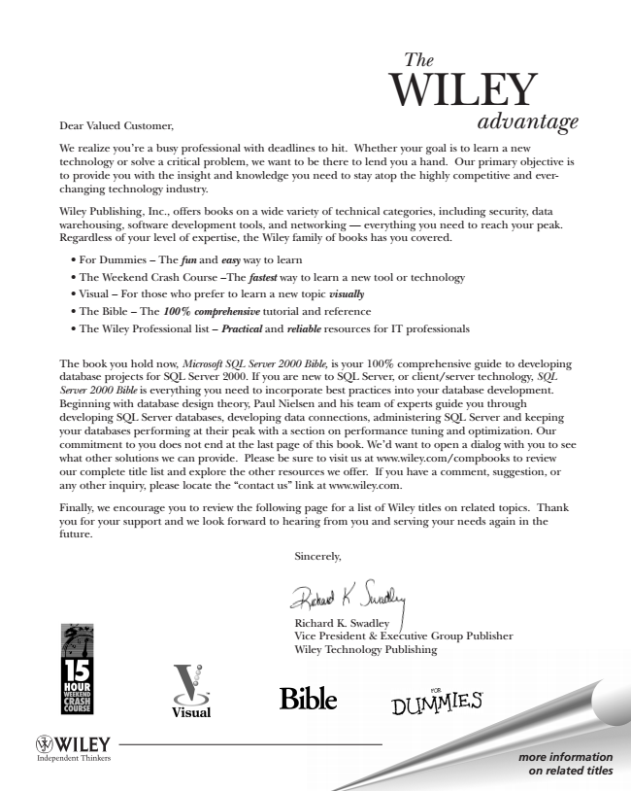

*The*

Dear Valued Customer,

WILEY

*advantage*

We realize you’re a busy professional with deadlines to hit. Whether your goal is to learn a new technology or solve a critical problem, we want to be there to lend you a hand. Our primary objective is to provide you with the insight and knowledge you need to stay atop the highly competitive and ever- changing technology industry.

Wiley Publishing, Inc., offers books on a wide variety of technical categories, including security, data warehousing, software development tools, and networking — everything you need to reach your peak. Regardless of your level of expertise, the Wiley family of books has you covered.

• For Dummies – The fun and easy way to learn

• The Weekend Crash Course –The fastest way to learn a new tool or technology

• Visual – For those who prefer to learn a new topic visually

• The Bible – The 100% comprehensive tutorial and reference

• The Wiley Professional list – Practical and reliable resources for IT professionals

The book you hold now, Microsoft SQL Server 2000 Bible, is your 100% comprehensive guide to developing database projects for SQL Server 2000. If you are new to SQL Server, or client/server technology, SQL Server 2000 Bible is everything you need to incorporate best practices into your database development. Beginning with database design theory, Paul Nielsen and his team of experts guide you through developing SQL Server databases, developing data connections, administering SQL Server and keeping your databases performing at their peak with a section on performance tuning and optimization. Our commitment to you does not end at the last page of this book. We’d want to open a dialog with you to see what other solutions we can provide. Please be sure to visit us at www.wiley.com/compbooks to review our complete title list and explore the other resources we offer. If you have a comment, suggestion, or any other inquiry, please locate the “contact us” link at www.wiley.com.

Finally, we encourage you to review the following page for a list of Wiley titles on related topics. Thank you for your support and we look forward to hearing from you and serving your needs again in the future.

Sincerely,

Richard K. Swadley Vice President & Executive Group Publisher Wiley Technology Publishing

***more information on related titles***

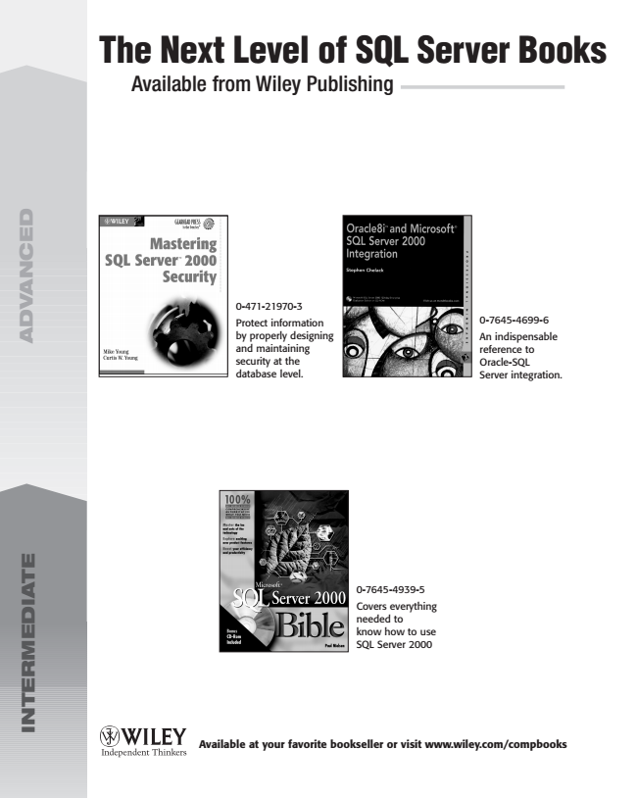

**A**

**D**

**V**

**A**

**N**

**C**

**E**

**D**

**I**

**N**

**T**

**E**

**R**

**M**

**E**

**D**

**I**

**A**

**T**

**The Next Level of SQL Server Books**

Available from Wiley Publishing

**Available at your favorite bookseller or visit www.wiley.com/compbooks**

0-471-21970-3 Protect information by properly designing and maintaining security at the database level.

**E**

0-7645-4939-5 Covers everything needed to know how to use SQL Server 2000

0-7645-4699-6 An indispensable reference to Oracle-SQL Server integration.

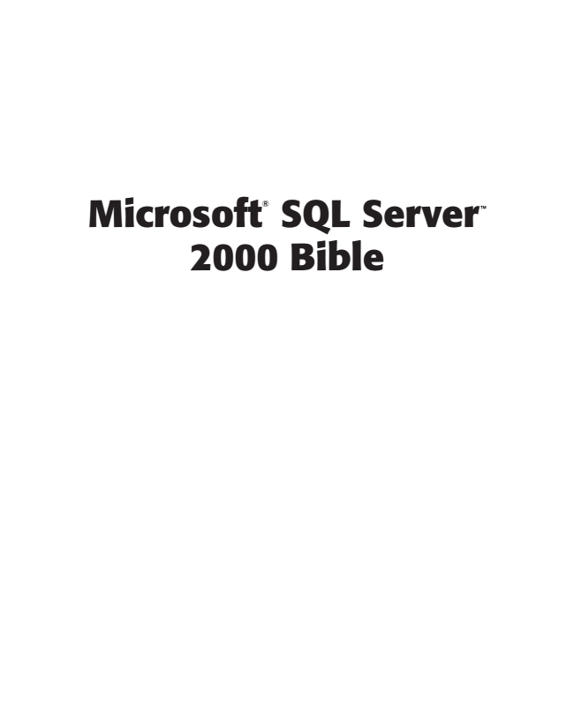

**SQL Microsoft**

®

**Server**

**TM 2000 Bible**



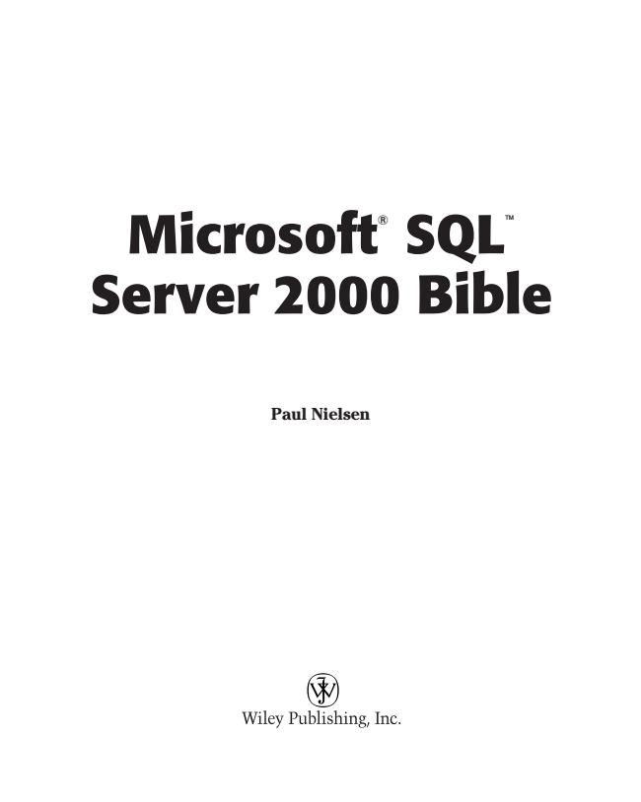

**Microsoft**

®

**SQL**

**TM Server 2000 Bible**

**Paul Nielsen**

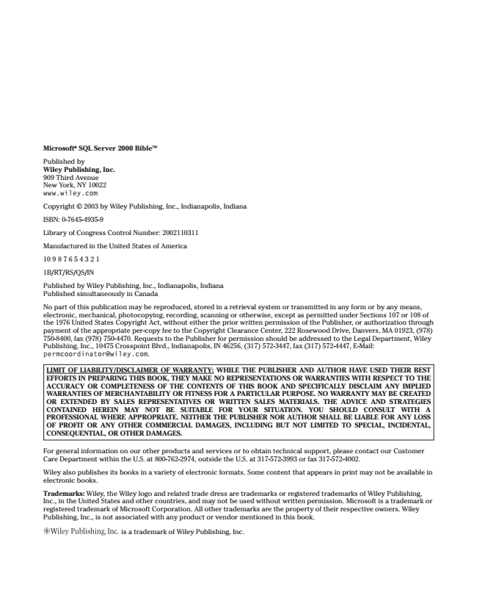

**Microsoft® SQL Server 2000 BibleTM**

Published by Wiley Publishing, Inc. 909 Third Avenue New York, NY 10022 www.wiley.com

Copyright © 2003 by Wiley Publishing, Inc., Indianapolis, Indiana

ISBN: 0-7645-4935-9

Library of Congress Control Number: 2002110311

Manufactured in the United States of America

10 9 8 7 6 5 4 3 2 1

1B/RT/RS/QS/IN

Published by Wiley Publishing, Inc., Indianapolis, Indiana Published simultaneously in Canada

No part of this publication may be reproduced, stored in a retrieval system or transmitted in any form or by any means, electronic, mechanical, photocopying, recording, scanning or otherwise, except as permitted under Sections 107 or 108 of the 1976 United States Copyright Act, without either the prior written permission of the Publisher, or authorization through payment of the appropriate per-copy fee to the Copyright Clearance Center, 222 Rosewood Drive, Danvers, MA 01923, (978) 750-8400, fax (978) 750-4470. Requests to the Publisher for permission should be addressed to the Legal Department, Wiley Publishing, Inc., 10475 Crosspoint Blvd., Indianapolis, IN 46256, (317) 572-3447, fax (317) 572-4447, E-Mail: permcoordinator@wiley.com.

**LIMIT OF LIABILITY/DISCLAIMER OF WARRANTY: WHILE THE PUBLISHER AND AUTHOR HAVE USED THEIR BEST EFFORTS IN PREPARING THIS BOOK, THEY MAKE NO REPRESENTATIONS OR WARRANTIES WITH RESPECT TO THE ACCURACY OR COMPLETENESS OF THE CONTENTS OF THIS BOOK AND SPECIFICALLY DISCLAIM ANY IMPLIED WARRANTIES OF MERCHANTABILITY OR FITNESS FOR A PARTICULAR PURPOSE. NO WARRANTY MAY BE CREATED OR EXTENDED BY SALES REPRESENTATIVES OR WRITTEN SALES MATERIALS. THE ADVICE AND STRATEGIES CONTAINED HEREIN MAY NOT BE SUITABLE FOR YOUR SITUATION. YOU SHOULD CONSULT WITH A PROFESSIONAL WHERE APPROPRIATE. NEITHER THE PUBLISHER NOR AUTHOR SHALL BE LIABLE FOR ANY LOSS OF PROFIT OR ANY OTHER COMMERCIAL DAMAGES, INCLUDING BUT NOT LIMITED TO SPECIAL, INCIDENTAL, CONSEQUENTIAL, OR OTHER DAMAGES.**

For general information on our other products and services or to obtain technical support, please contact our Customer Care Department within the U.S. at 800-762-2974, outside the U.S. at 317-572-3993 or fax 317-572-4002.

Wiley also publishes its books in a variety of electronic formats. Some content that appears in print may not be available in electronic books.

Trademarks: Wiley, the Wiley logo and related trade dress are trademarks or registered trademarks of Wiley Publishing, Inc., in the United States and other countries, and may not be used without written permission. Microsoft is a trademark or registered trademark of Microsoft Corporation. All other trademarks are the property of their respective owners. Wiley Publishing, Inc., is not associated with any product or vendor mentioned in this book.

is a trademark of Wiley Publishing, Inc.

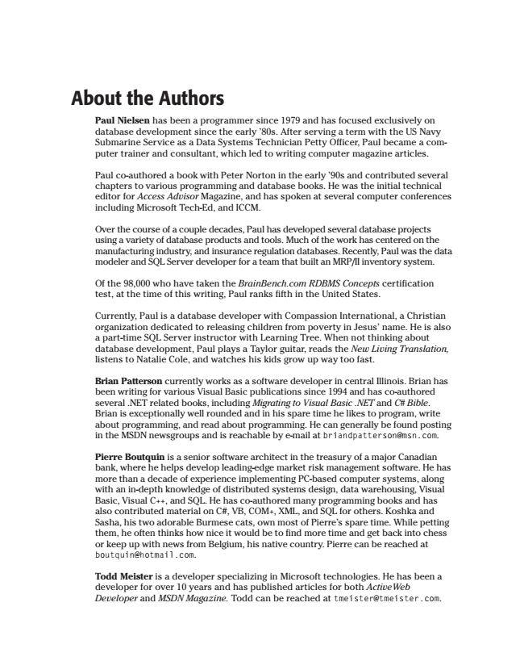

**About the Authors**

Paul Nielsen has been a programmer since 1979 and has focused exclusively on database development since the early ’80s. After serving a term with the US Navy Submarine Service as a Data Systems Technician Petty Officer, Paul became a com- puter trainer and consultant, which led to writing computer magazine articles.

Paul co-authored a book with Peter Norton in the early ’90s and contributed several chapters to various programming and database books. He was the initial technical editor for Access Advisor Magazine, and has spoken at several computer conferences including Microsoft Tech-Ed, and ICCM.

Over the course of a couple decades, Paul has developed several database projects using a variety of database products and tools. Much of the work has centered on the manufacturing industry, and insurance regulation databases. Recently, Paul was the data modeler and SQL Server developer for a team that built an MRP/II inventory system.

Of the 98,000 who have taken the BrainBench.com RDBMS Concepts certification test, at the time of this writing, Paul ranks fifth in the United States.

Currently, Paul is a database developer with Compassion International, a Christian organization dedicated to releasing children from poverty in Jesus’ name. He is also a part-time SQL Server instructor with Learning Tree. When not thinking about database development, Paul plays a Taylor guitar, reads the New Living Translation, listens to Natalie Cole, and watches his kids grow up way too fast.

Brian Patterson currently works as a software developer in central Illinois. Brian has been writing for various Visual Basic publications since 1994 and has co-authored several .NET related books, including Migrating to Visual Basic .NET and C# Bible. Brian is exceptionally well rounded and in his spare time he likes to program, write about programming, and read about programming. He can generally be found posting in the MSDN newsgroups and is reachable by e-mail at briandpatterson@msn.com.

Pierre Boutquin is a senior software architect in the treasury of a major Canadian bank, where he helps develop leading-edge market risk management software. He has more than a decade of experience implementing PC-based computer systems, along with an in-depth knowledge of distributed systems design, data warehousing, Visual Basic, Visual C++, and SQL. He has co-authored many programming books and has also contributed material on C#, VB, COM+, XML, and SQL for others. Koshka and Sasha, his two adorable Burmese cats, own most of Pierre’s spare time. While petting them, he often thinks how nice it would be to find more time and get back into chess or keep up with news from Belgium, his native country. Pierre can be reached at boutquin@hotmail.com.

Todd Meister is a developer specializing in Microsoft technologies. He has been a developer for over 10 years and has published articles for both ActiveWeb Developer and MSDN Magazine. Todd can be reached at tmeister@tmeister.com.

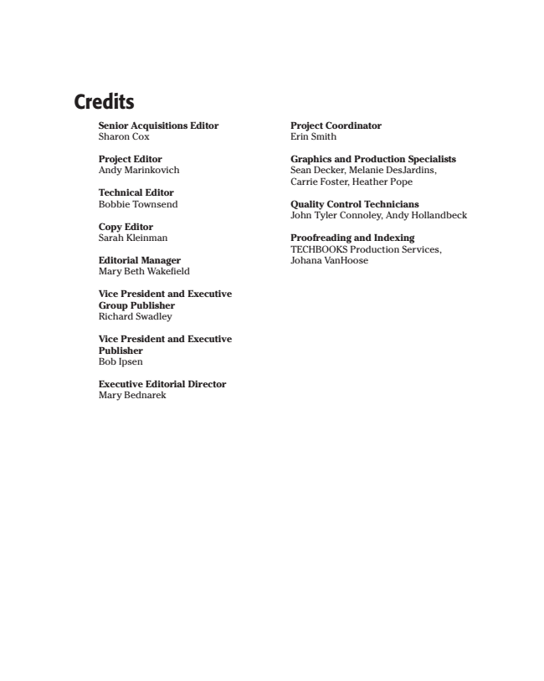

**Credits**

**Senior Acquisitions Editor Sharon Cox**

Project Editor Andy Marinkovich

**Technical Editor Bobbie Townsend**

Copy Editor Sarah Kleinman

Editorial Manager Mary Beth Wakefield

**Vice President and Executive Group Publisher Richard Swadley**

**Vice President and Executive Publisher Bob Ipsen**

**Executive Editorial Director Mary Bednarek**

**Project Coordinator Erin Smith**

Graphics and Production Specialists Sean Decker, Melanie DesJardins, Carrie Foster, Heather Pope

Quality Control Technicians John Tyler Connoley, Andy Hollandbeck

Proofreading and Indexing TECHBOOKS Production Services, Johana VanHoose